Amani Mohammed Abdel moety Elsisi | Name:
Beni suef | Place of birth:
11-12-1981 | Date of birth:
Egyptian | Nationality :
Arabic- English- Frensh ( bien mais n'est pas tre's forte ) | Language :
Pharmaceutics & industrial pharmacy | General specialization:
Pharmaceutics & industrial pharmacy | Accurate specialization:
0233800806  01027700083 / 01016822282 | Home phone:  Mobile phone
amani_mcc@hotmai.com | E-mail:

Pharmaceutics & Industrial Pharmacy Lecturer CV.

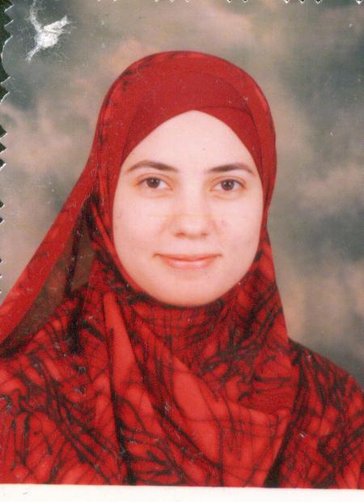
1-Personal data:

Country | Affiliation | Faculty | General specification | Date | Degree
Egypt | Cairo University – Beni Suef Branch | Pharmacy | Pharmacy & Pharmaceutical Sciences | 2003 | BS.C
Egypt | Cairo University | pharmacy | Pharmaceutics & Industrial pharmacy | 2009 | master
Egypt | Beni Suef University | pharmacy | Pharmaceutics and Industrial pharmacy | 2014 | PH.D

2-Scientific qualification:

3-Chronology of Employment:
Country | Affiliation | The end of employment | The start of employment | Academic degree | Job
Egypt | Beni suef university | 2009 | February-2004 | BS.C | demonstrator
Egypt | Beni suef university | 2014 | May-2009 | master | Lecturer assistant
Egypt | Beni suef university | --- | December-2014 | PH.D | lecturer

4- The scientific production:

A-Scientific dissertation:-
Specialization | Date | Faculty / Department | Donator university | Title of thesis | Scientific dissertation
Pharmaceutics and Industrial pharmacy | 2009 | Faculty of pharmacy-Pharmaceutics and Industrial pharmacy | Cairo university | "A Pharmaceutical Study on Thioctic Acid" | master
Pharmaceutics and Industrial pharmacy | 2014 | Faculty of pharmacy-Pharmaceutics and Industrial pharmacy | Beni suef university | “A Pharmaceutical Study on Fast Release Solid Dosage Forms of Risperidone for Optimization of Its Clinical Effect" | PH.D

B-Papers:-
Accurate specialization | Publication data |  | Name of journal | Author/s | Title
 | Volume | Year
Pharmaceutics and Industrial pharmacy | 30(2), January -February | 2015 | International Journal of Pharmaceutical Sciences Review and Research | Amani M. El Sisi, Rasha M.Kharshoum, Adel A. Ali, Khaled M. Hosny, Ahmed Abd-Elbary | Preparation and Evaluation of Risperidone Oro-dispersible Tablets

C-Conferences:-
Accurate specialization | Year | Place | Sponsor | Conference title | Author/s | Research title
Pharmaceutics and Industrial pharmacy | 2011 | Egypt, Cairo | EPS | International Egyptian pharmaceutical society XXXII conference of pharmaceutical sciences | Amani M. El Sisi, Adel A. Ali, Khaled M. Hosny, Ahmed Abd-Elbary | The formulation of orodispersible tablets of Risperidone by effervescent method.
Pharmaceutics and Industrial pharmacy | 2015 | UAE-Dubai | Omics | 5th International Conference and Exhibition on Pharmaceutics & Novel Drug Delivery Systems | Amani M. El Sisi, Rasha M.Kharshoum, Adel A. Ali, Khaled M. Hosny, Ahmed Abd-Elbary | Preparation and Evaluation of Risperidone Fast Dissolving Films

5- Courses and workshops:
Year | place | Name of course
2010 | Ein shams university | 6th technical training programme in Pharmaceutical compounding calculations, parenteral solutions and clinical pharmacy practice
2011 | Beni-suef university | Recent Advances in Pharmaceutical Research
2015 | IBCT | ToT

6-Teached courses:
Accurate specialization | University | Faculty | Grade | Language | Course name
Pharmaceutics and Industrial pharmacy | Beni suef | pharmacy | 5th | english | Quality control
Pharmaceutics and Industrial pharmacy | Beni suef | pharmacy | 4th | english | pharmacokinetics
Pharmaceutics and Industrial pharmacy | Beni suef | pharmacy | 2nd | arabic | legalization

7-Teached practical courses: (in English):
1- Courses in Preformualtion & Pharmacuetical Dosage Forms; including:

-Dosage form 1 : Solution, Suspension, Emulsion.

-Dosage form 2 : Creams, Suppository, Ointments, Tablets, Capsules,…etc.

2- Courses in Physical Pharmacy; including:

- Buffers, partition coefficient, solubility,…etc.

3- Courses in Kinetics & Isotonisity; including:

4- Courses in Clinical Pharmacy; including:

- Hospital Pharmacy.

- Community.

- Clinical pharmacy.

5- Courses in Industrial Pharmacy; including:

-Size enlargement, size reduction, spray drying,..etc.

6- Courses in Quality Control; including:

-Tablets, Capsules, Suspension…etc.

