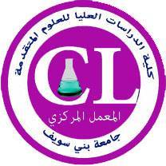

**Contact us**

# Address :Beni-Suef University , East of the Nile , beside Faculty of Industrial Education.

# Mobile :01224209924 - 01012640836

**Email :central.lab166@gmail.com**

**ـــــــــــــــــــــــــــــــــــــــــــــــــــــــــــــــــــــــــ**

**X – ray Diffraction**

**Model : 202964 PANalytical Empyrean**

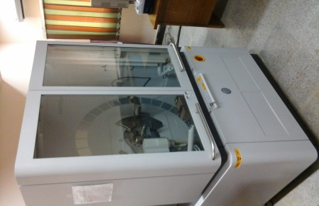**The technique uniquely provides phase identification (e.g. graphite or diamond), along with phase quantification and crystallite size for all powdered samples.**

**GC - MS**

**GC system 7890A/5975C Inert MS with triple Axis Detector - Agilent Technologies**

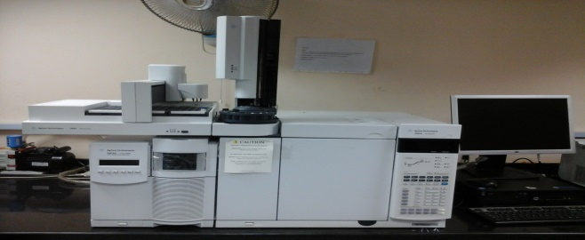

**GC-MS is an analytical method used for separation and analysis of the compounds that can be vaporized without decomposition. It is combined with mass spectroscopy to identify different substances within a sample.**

**HPLC – MS**

**Agilent Technologies Infinity 1260**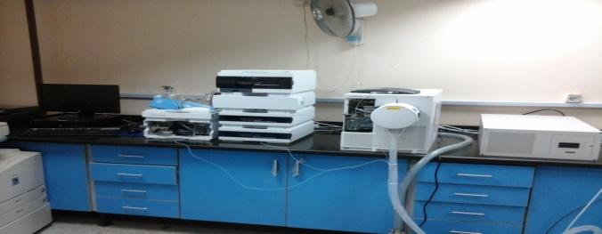

**HPLC-MS is an analytical technique used for separation of compounds that are thermally unstable and exhibit high polarity. It is combined with mass spectroscopy to identify different components within a sample.**

**Atomic absorption spectroscopy**

**Model: 200 series AA Agilent Technologies**

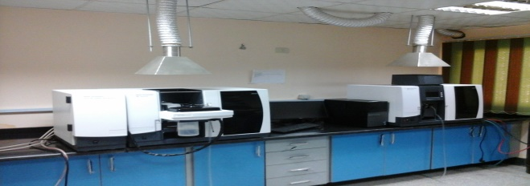

**It is used to identify the presence and the accurate concentration of substances in ppm and ppb by analyzing the spectrum produced when a substance is vaporized and absorbs certain frequencies of light.**

**FT-IR and FT-Raman**

**VERTEX 70 FT-IR spectrometer coupled to a RAM II FT-Raman module .**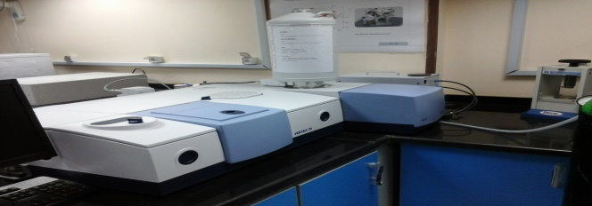

**Infrared spectroscopy is used to identify the presence of certain functional groups in a molecule. Raman is complementary to IR which measure compounds which IR inactive such as inorganic compounds which have no dipole moments.**