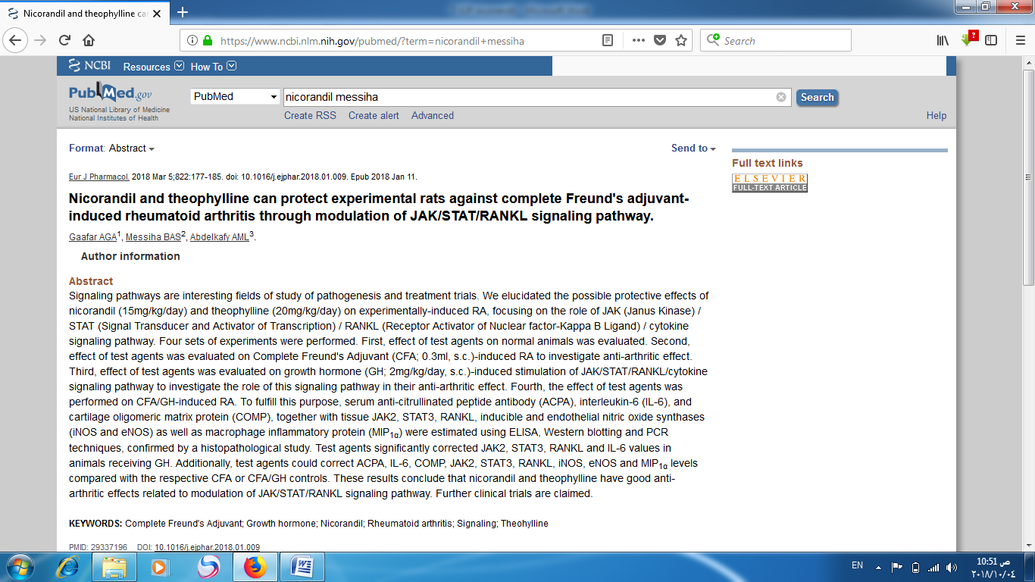<https://www.ncbi.nlm.nih.gov/pubmed/?term=nicorandil+messiha>